**SOFTWARE ENGINEERING PROJECT**

**on**

**Online Video Database Management System**

**Name: Pratik Kumar**

**Class: CSE-II (C)**

**Serial No: 48**

**Enrolment No: 10415002720**

Submitted To:

Ms. Shaily Malik



**Maharaja Surajmal Institute of Technology,**

**C-4 Janak Puri, New Delhi 110058**

**Problem Statement**

Online Video Database Management System refers to management of an online video database. The best example is the YouTube. So, users can watch videos without possessing them, upload videos and earn money etc,. Administrator must manage the online video database by adding or deleting videos from it etc,. The online video database management system for which the UML diagrams are drawn here is pretty much different from YouTube. A major difference in this system is that, user can access the online video database only if he/she has an account and logs in to the system which is not needed in YouTube.

**User Interface**

1) **Login Page** : Users can enter User Id and Password to login or can create a new account.

2) **Search Page** : This page is opened after a successful login. Users can enter a search term to search any video. The search results are displayed in the non-header part of the page. Each search result shows name, thumbnail, download button (for free videos), like and dislike icons, number of views etc., corresponding to a video. Also, an upload button is located at the top right corner of the page.

3) **Download Page** : If on the search page, download button corresponding to a video is clicked, a dialog box is displayed asking to set resolution and format. After selection of required resolution and format, this page is opened showing the percentage of download completed etc,. User cannot do any work until the download is completed or cancelled. So, network connection must be good.

4) **Watch Page** : If on the search page, name corresponding to a video is clicked, this page is opened if the video is a free video else a dialog box requesting to rent/purchase video is opened. A Non Free video is displayed if and only if it is taken for rent or purchased by the user. Unlike YouTube, video is shown full screen only and only play/pause, replay, close etc,. buttons are present on this page.

5) **Upload Page** : If on the search page, upload button is clicked, this page is opened and asks to select a video and fill the details required. After selection of video and filling the details, the video is uploaded to the administrator database and gets ready for processing.

6) **Process Page** : After the upload of video into the administrator database from the upload page, this page opens automatically showing the details of processing.

After 'close button click' on Watch Page or 'completion or cancellation of download' in Download Page or 'completion of processing' in Process Page, Search Page is automatically displayed. *Sign In Page, Edit Profile Page etc,.* are similar to YouTube in this system.

**Actors**  
User : Uses the online video database.

Administrator : Manages the online video database.

**Use Cases**

Sign Up : User creates a new account.

Sign In : User logs in to the system.

Search Video : User enters a search term.

Watch Video : User watches a video.

Download Video : User downloads a video.

Upload Video : User uploads a video.

Manage Account : User performs edit profile or delete account.

Sign Out : User logs out from the system.

Verify Login : Administrator verifies login details of users.

Manage Accounts : Administrator manages user accounts.

Search Video : Administrator searches for a video in the database.

Play Video : Administrator streams a video from the database.

Rent/Sell Video : Administrator manages money transactions.

Process Video : Administrator processes video uploaded by users.

Maintain Database : Administrator maintains video database.

**Data Flow Diagram(DFD)**

* **Level 0 - DFD**

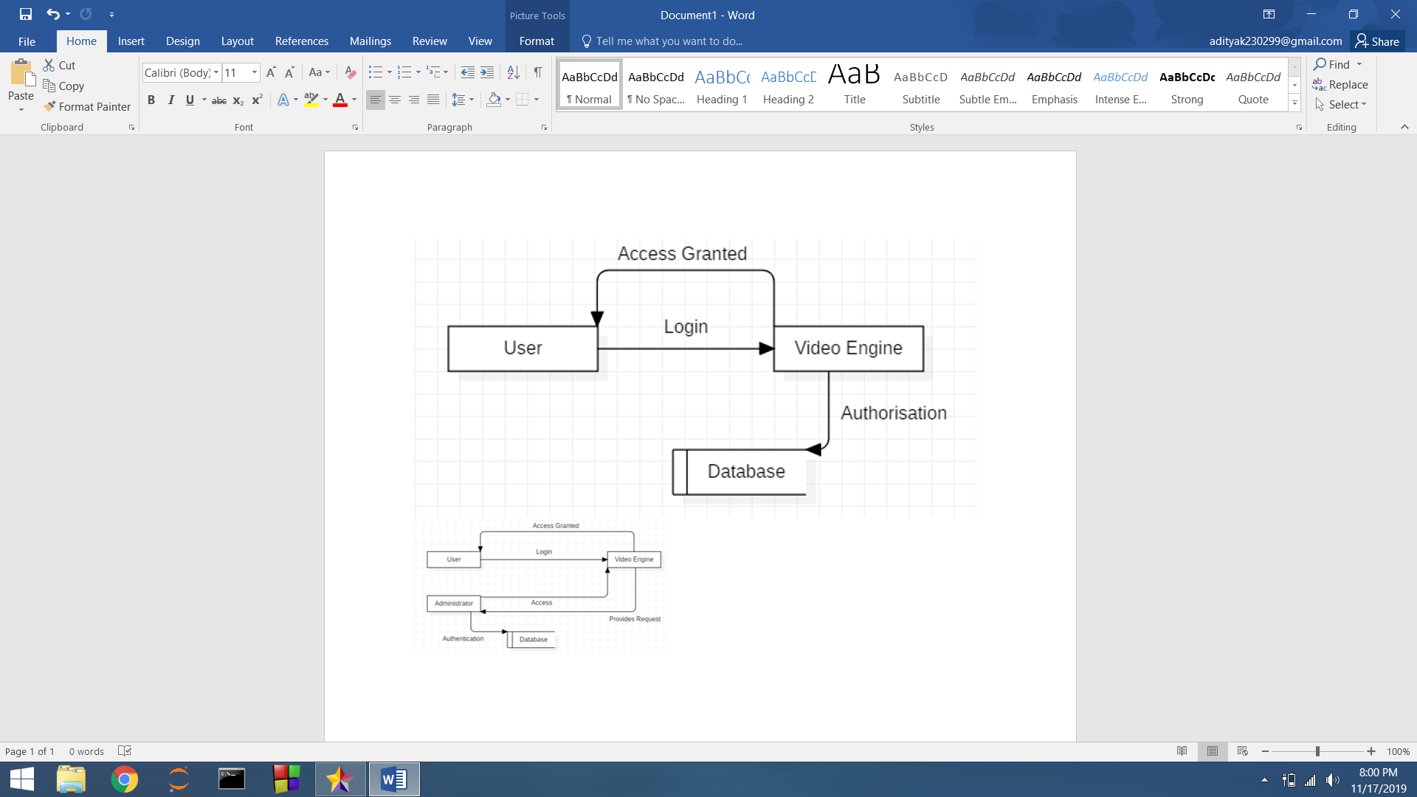

* **Level 1 – DFD**

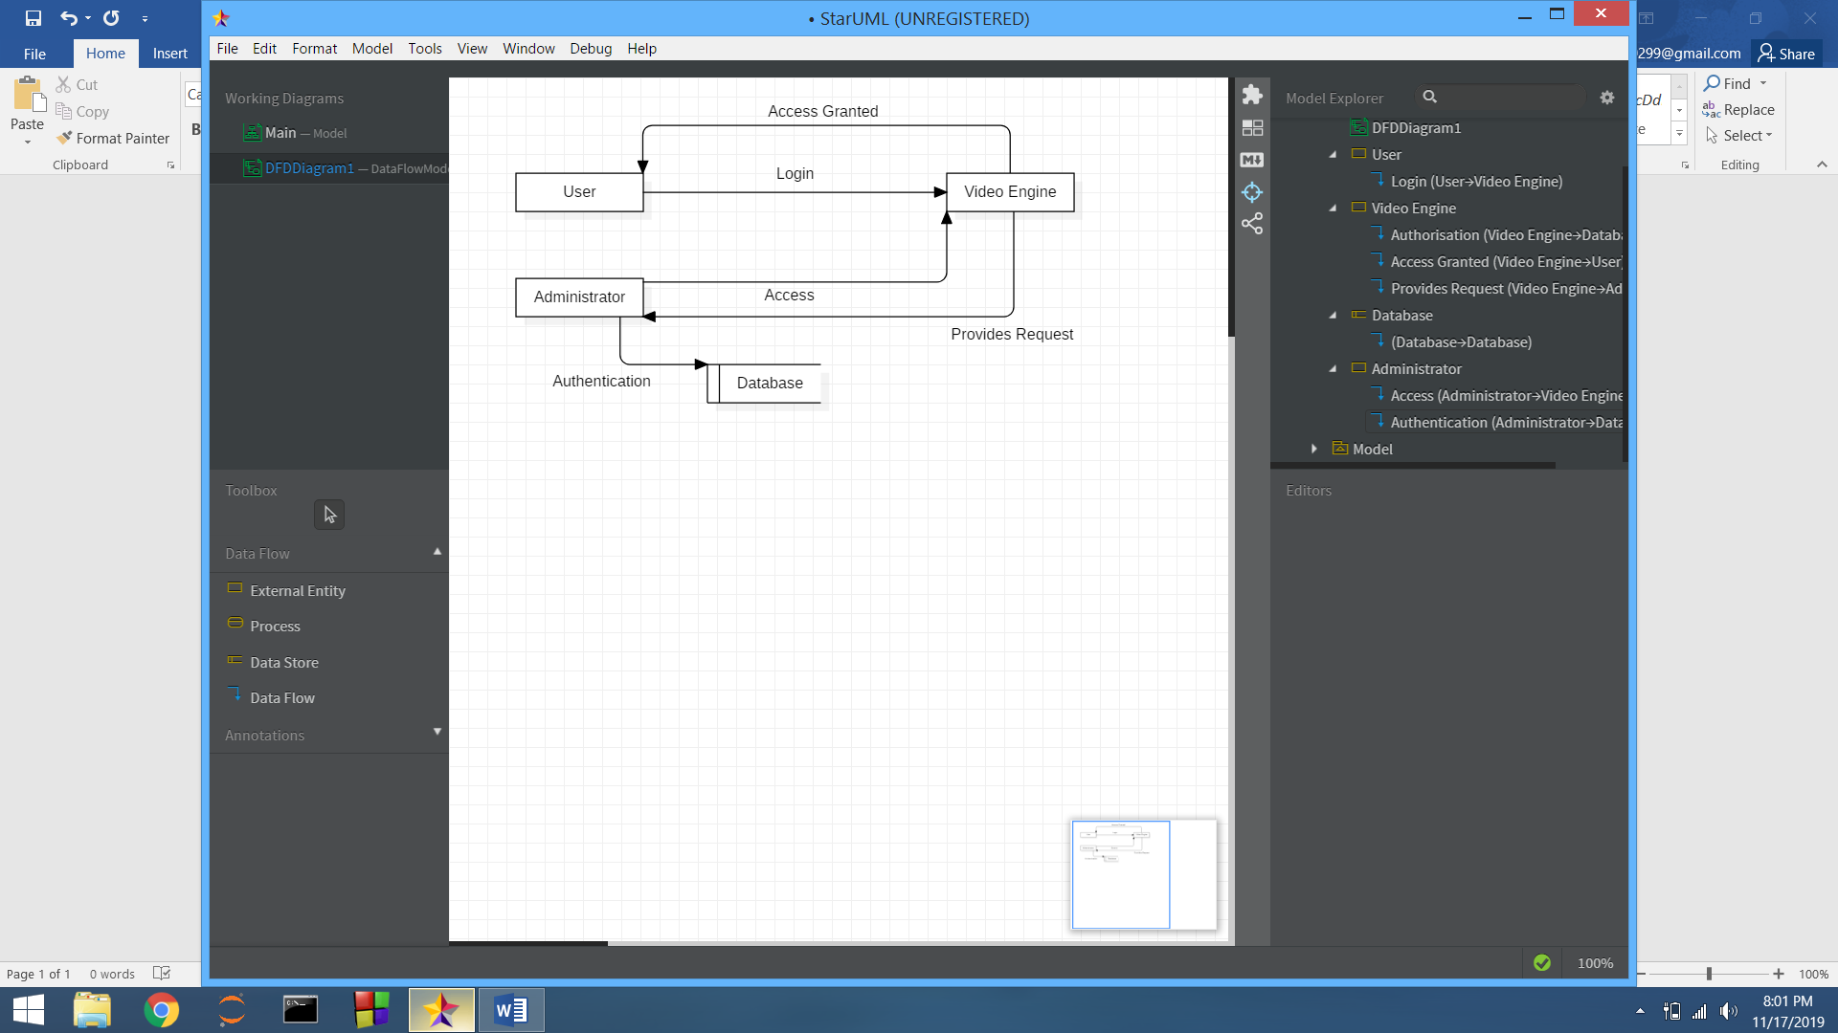

**Use Case Diagram for Using Online Video Database**

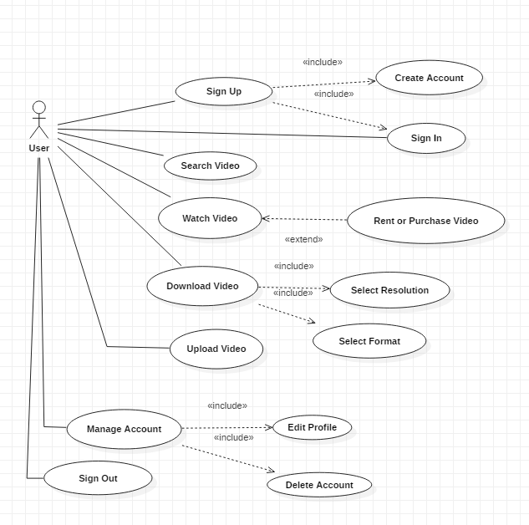

**Use Case Diagram for Managing Online Video Database**

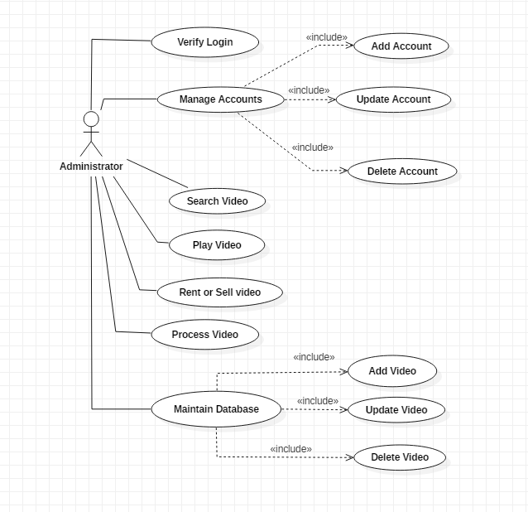

**Class Diagram**

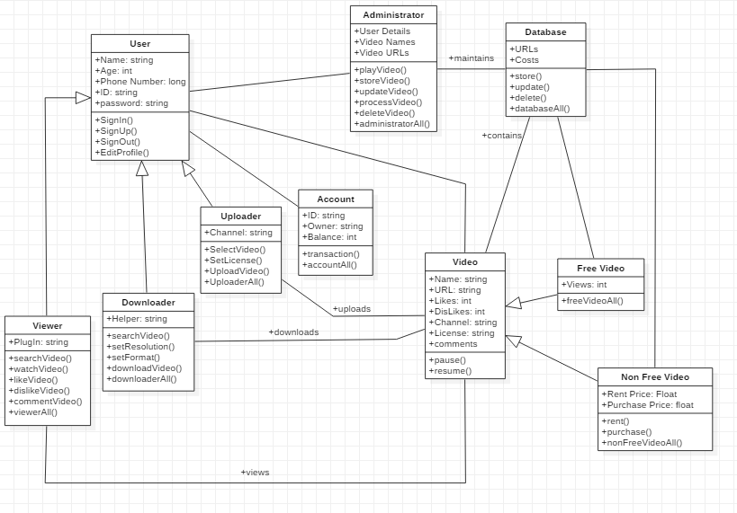

**Sequence Diagram for Watch Video**

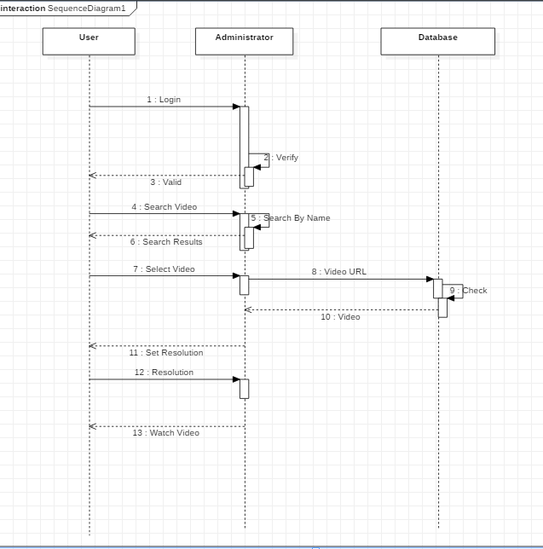

**Sequence Diagram for Download Video**

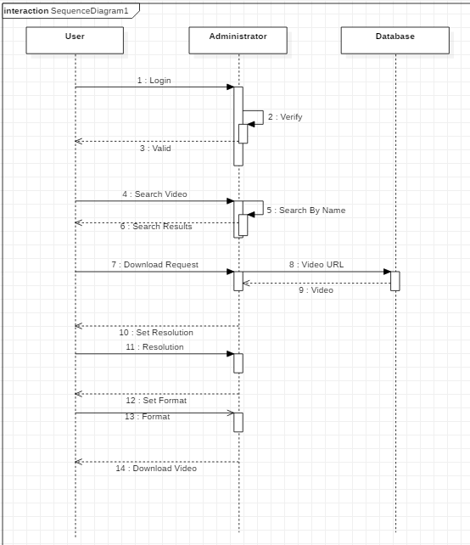

**Sequence Diagram for Upload Video**

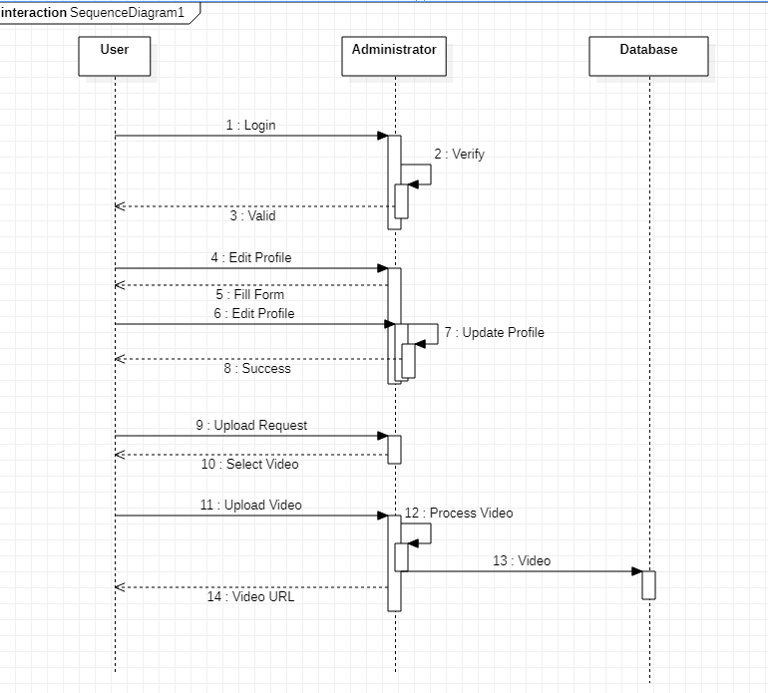

**Collaboration Diagram for Download Video**

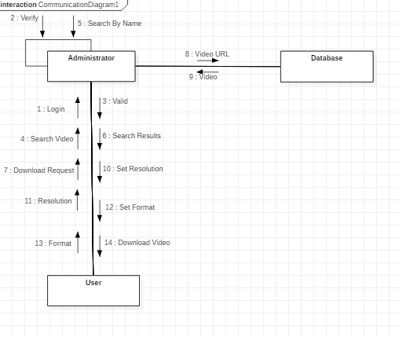

**Collaboration Diagram for Watch Video**

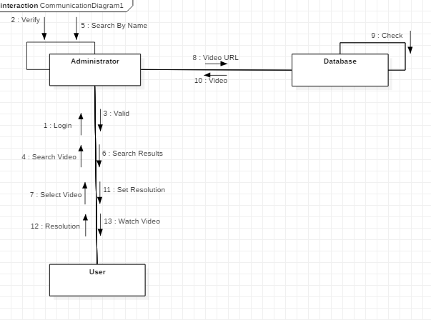

**Collaboration Diagram for Upload Video**

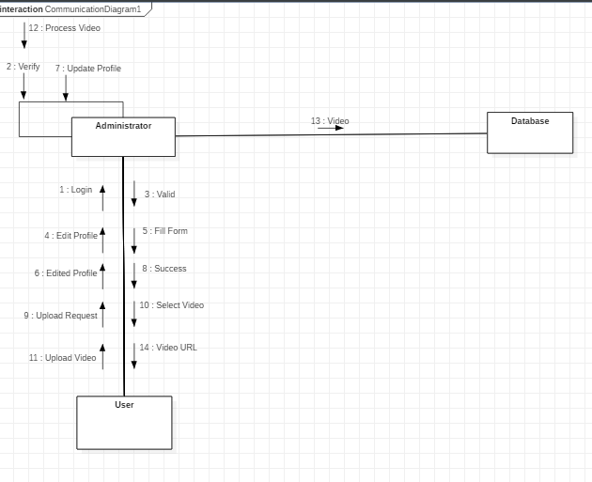

**State Chart Diagram**

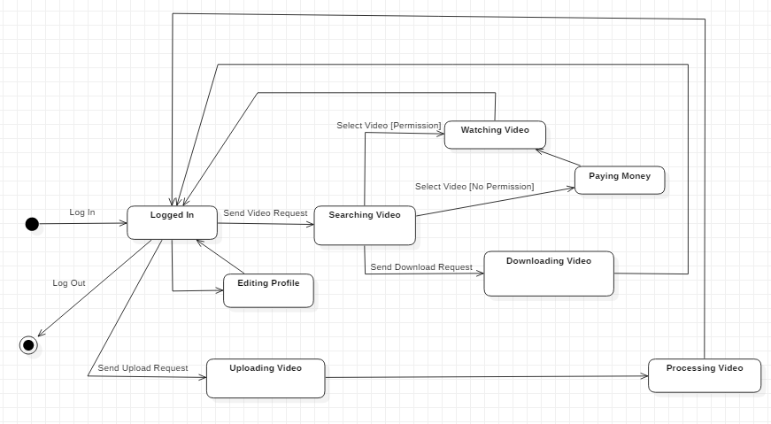

**Component Diagram**

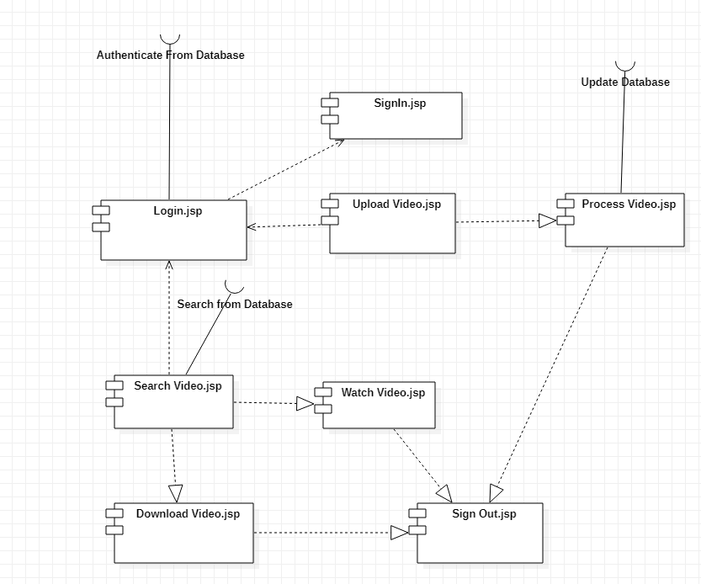

**Deployment Diagram**

